**Appendix D: Sequence Diagram**

Info of SMS App

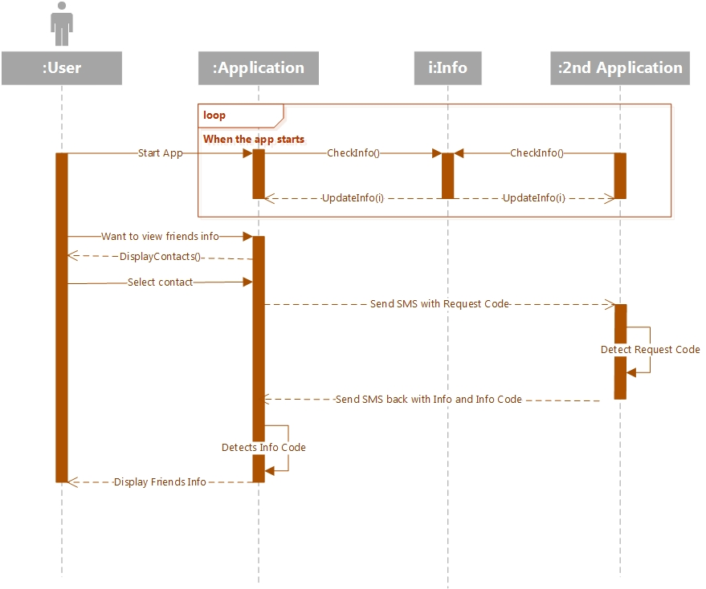

Info of Server App

